# How to encrypt a wallet

First, let's open our wallet (in this case Trittium).

After this, as we can see in the image below, there is a padlock icon that is used to encrypt our wallet.

**It is important to encrypt our wallet to ensure greater security for our coins.**



Now let's click on the padlock icon and the following window will open  
**We recommend that you put a secure password that is not already used elsewhere.**

**It is important to take care not to lose this password because without the password it will no longer be possible to access funds.**

Then we click the OK button  
  
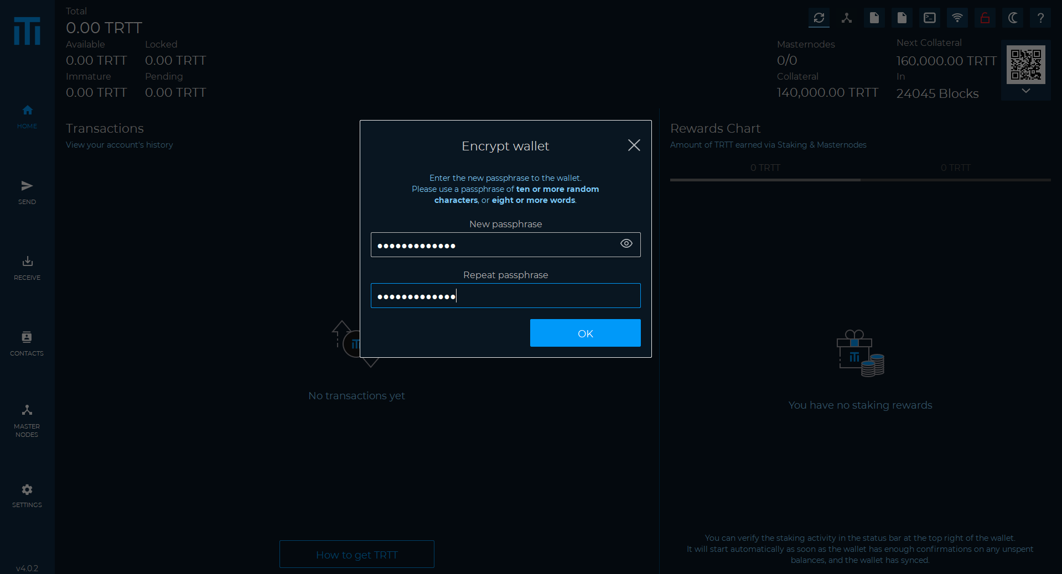

A further confirmation screen will open so press the ENCRYPT button  
  
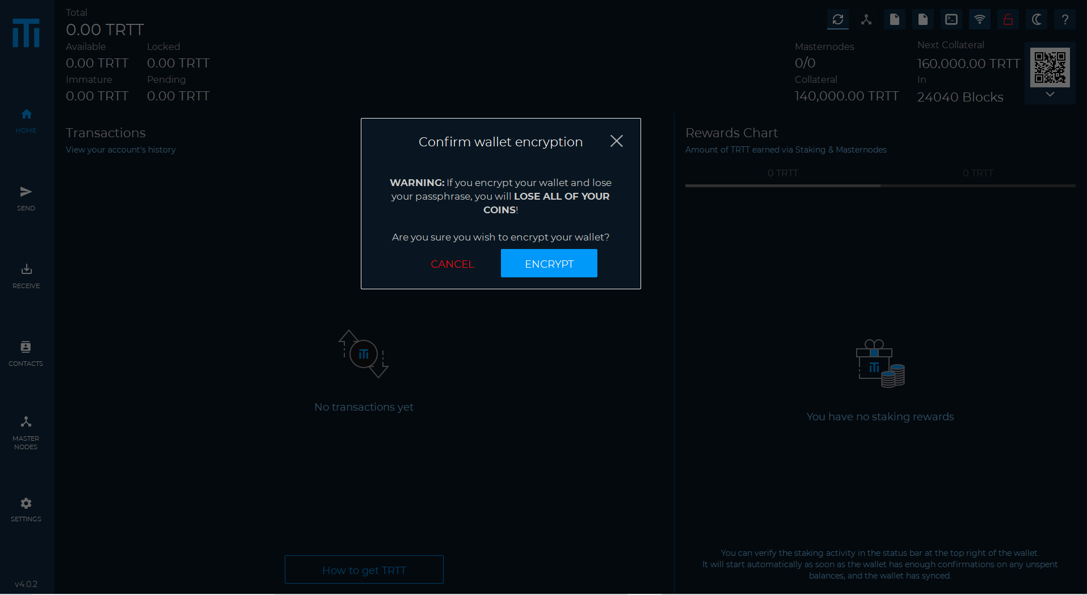

Once this is done, a further confirmation window will open and the wallet will be closed to complete the operation.

As in the next image

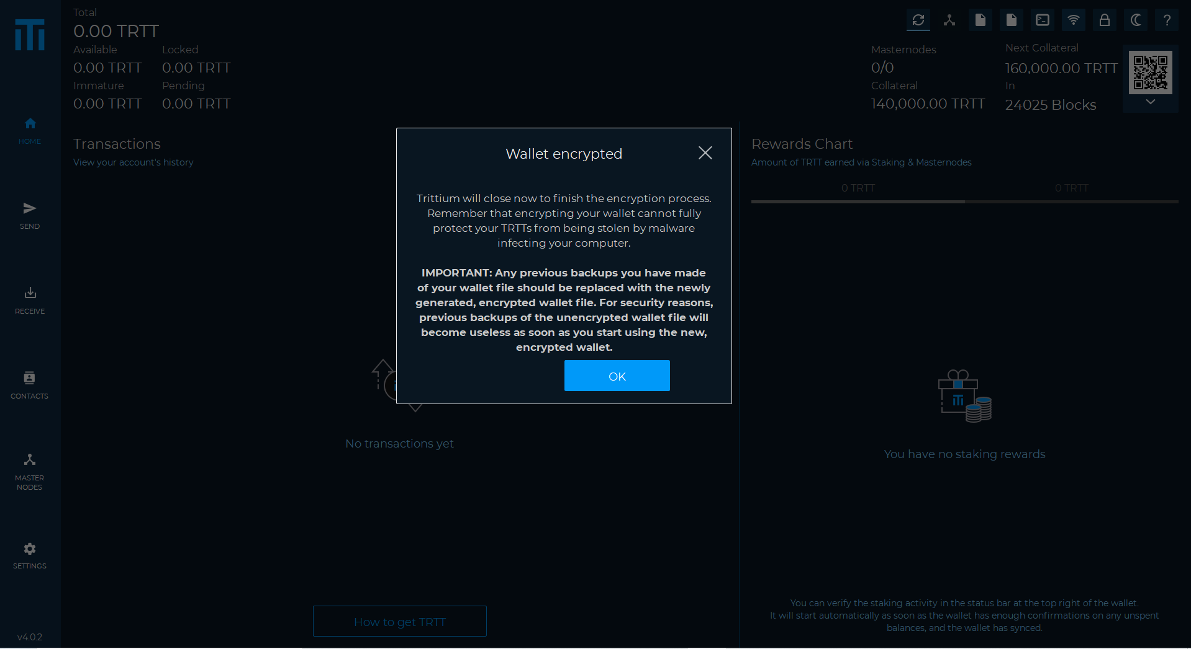

Now we can restart our wallet and as we can see in the image below it will be encrypted.

You will be required to enter your password in case you want to send funds or perform other operations that require it.

